IN723 Lab 2 MPLS VPN (VIRL)

In this lab we will build upon lab1 (base LDP config) and add in support for MPLS VPNs. In this lab 2 companies share the same service provider infrastructure. MPLS VPNs can also be used to isolate traffic for specific security / policy reasons within a large enterprise. Specifically, it allows isolation of traffic from the core network and minimizes the need for firewall filtering.
Note – This lab cannot be completed in packet tracer
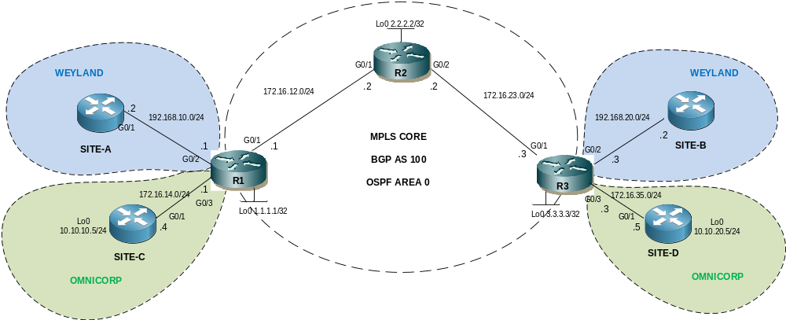

- The switches are used to allow multiple students to simulatenously connect to the routers using telnet.
IP Addressing
Interface | IP Address | Notes | VRF Forwarding
R1 G0/2 | 192.168.10.1/24 | R1 - SITE-A | WEYLAND
R1 G0/1 | 172.16.12.1/24 | R1 – R2
R1 G0/3 | 172.16.14.1/24 | R1 – SITE-C | OMNICORP
R1 Lo0 | 1.1.1.1/32 | Loopback
R2 G0/1 | 172.16.12.2/24 | R2 – R1
R2 G0/2 | 172.16.23.2/24 | R2 – R3
R2 Lo0 | 2.2.2.2/32 | Loopback
R3 G0/2 | 192.168.20.3/24 | R3 – SITE-B | WEYLAND
R3 G0/1 | 172.16.23.3/24 | R2 – R3
R3 G0/3 | 172.16.35.3/24 | R3 – SITE-D | OMNICORP
R3 Lo0 | 3.3.3.3/24 | Loopback
SITE-A G0/1 | 192.168.10.2/24 | SITE-A – R1
SITE-B G0/1 | 192.168.20.2/24 | SITE-B – R3
SITE-C Lo0 | 10.10.10.4/24 | SITE-C LAN
SITE-C G0/1 | 172.16.14.4/24 | SITE-C – R1
SITE-D Lo0 | 10.10.20.5/24 | SITE-D LAN
SITE-D G0/1 | 172.16.35.5/24 | SITE-D – R3

Step 1 - Physical
- Physically cable the lab as per the above diagram using IOSv nodes.

Step 2 – PE to P IP addressing
- Configure IP addressing on R1 connection to R2, & R2 to R3 as per the diagram / table. Do not configure the LAN interfaces (facing SITES A – D) yet.

Step 3 – CE addressing
- Configure IP addressing on SITE-A, SITE-B, SITE-C, SITE-D as per the diagram / table.

Step 4 – OSPF
- Configure single area OSPF between R1, R2 & R3. Use the loopback addresses as router-ids
- Advertise loopbacks vis OSPF (needed for MPLS LDP peering)

Step 5 – MPLS LDP
- Confirm CEF is enabled (show ip cef) on each P & PE router.
- Configure the MPLS label protocol as ldp (mpls ldp label protocol ldp) on R1, R2 & R3
- Configure the MPLS ldp router-id as the loopback on each router (mpls ldp router-id loopback 0)
- Enable MPLS forwarding on the WAN interfaces of R1, R2 & R3 (mpls ip)
- Verify MPLS neighbors (show mpls ldp neighbor)

Step 6 – MP-BGP PE to PE
- Configure MP-BGP (iBGP) between R1 and R3. Note that with MPLS VPNs, next-hop self is not required as the PE will re orginate routes learned from the CE, though having turned on will not harm and is often seen in practice. Note P nodes do not participate in BGP, their role is simply to switch labelled packets.

R1 config
router bgp 100
bgp router-id 1.1.1.1
no bgp default ipv4-unicast
bgp log-neighbor-changes
neighbor 3.3.3.3 remote-as 100
neighbor 3.3.3.3 description PE R3
neighbor 3.3.3.3 update-source Loopback0
!
address-family vpnv4
neighbor 3.3.3.3 activate
neighbor 3.3.3.3 send-community extended

R3 Config
router bgp 100
bgp router-id 3.3.3.3
bgp log-neighbor-changes
no bgp default ipv4-unicast
neighbor 1.1.1.1 remote-as 100
neighbor 1.1.1.1 description PE R1
neighbor 1.1.1.1 update-source Loopback0
!
address-family vpnv4
neighbor 1.1.1.1 activate
neighbor 1.1.1.1 send-community extended

Step 7 – Confirm MP-BGP
- Verify MP-BGP peering
show ip bgp vpnv4 all summary

Step 8 – Define VRFs
- Configure VRFs WEYLAND & OMNICORP on R1 & R3 as per the following
ip vrf WEYLAND
rd 100:100
route-target export 100:100
route-target import 100:100
!
ip vrf OMNICORP
rd 200:200
route-target export 200:200
route-target import 200:200

Step 9 – Attach VRFs to interfaces and configure IP addressing
- Configure the LAN interfaces on R1 & R3 in the correct VRF as per the IP addressing table
e.g for R1 – SITEA
interface g0/2
ip vrf forwarding WEYLAND

- Configure IP addressing for the LAN interfaces on R1 & R3 as per the IP addressing table
Confirm with:
show ip vrf interfaces

Step 10 – PE to CE WEYLAND
- Configure R1 to advertise SITEA into the WEYLAND VPN using redistribute connected
router bgp 100
address-family ipv4 vrf WEYLAND
redistribute connected

- Configure R3 to advertise SITEB into the WEYLAND VPN using the BGP network command
router bgp 100
address-family ipv4 vrf WEYLAND
network 192.168.20.0 mask 255.255.255.0

Step 11 – PE to CE OMNICORP
- Configure R1 and SITE-C to advertise SITE-C’s loopback into the OMNICORP VPN using BGP.
R1
router bgp 100
address-family ipv4 vrf OMNICORP
neighbor 172.16.14.4 remote-as 400
neighbor 172.16.14.4 activate

SITE-C
router bgp 400
neighbor 172.16.14.1 remote-as 100
network 10.10.10.0 mask 255.255.255.0

- Configure R3 and SITE-D (BGP AS 500) to advertise SITE-D’s loopback network into the OMNICORP VPN using BGP using the above example to help.

Step 12 – Verify VPN routes
- View the BGP VPN tables on R1 and R3 (note R2 does not participate in BGP and has no knowledge of the VPN routes).
show ip bgp vpnv4 all
Note the next hop is the remote PE (1.1.1.1 or 3.3.3.3)

Step 13 – Verify VPN labels
- Use the following command to view the VPN label assigned to the prefix. Note this will be the bottom label of the 2 label stack as the packet is forwarded over the MPLS core. The remote PE router will use this label to determine which VRF to perform a route lookup for the packet’s destination IP address.
show ip bgp vpnv4 all labels

Step 14 – Verfiy MPLS LDP label mappings
- View the LIB (label information base) on R2 to see next-hop labels learned from downstream neighbors (& locally generated) mapped to IP prefixes
show mpls ldp bindings
- View the LFIB (label forwarding information base) on R2 to see the local label to next-hop label mappings along with the outgoing interface
show mpls forwarding table
- Note that these label mappings relate to the IGP label, which is the top label of the stack. This is the same label we observed in lab1

Step 15 – Confirm connectivity
- Confirm PCA can ping PCB
- Confirm PCC can ping PCD

Step 16 – View MPLS label operation in action
- Send a continuous ping from PCA to PCB (or PCC to PCD)
- Use the debug command to view MPLS forwarding in real time on R2
debug mpls packet
- Note that the debug shows both labels in the stack. The bottom label determines the VPN. The top label is used to traverse the MPLS core and is swapped at each hop, before popped (removed) at the penultimate hop.
Note - if debugging is already enabled on the router & is not showing up (default for telnet access) then use the command term mon to view the debug output. To turn off debugging use undebug all

